Project Design Phase
Solution Architecture

Date | 31 July 2026
Team ID
Project Name | An employee requests installation of licensed software through the Service Catalog
Maximum Marks | 4 Marks

Solution Architecture:
Solution architecture is a complex process – with many sub-processes – that bridges the gap between business problems and technology solutions. Its goals are to:
- Find the best tech solution to solve existing business problems.
- Describe the structure, characteristics, behavior, and other aspects of the software to project stakeholders.
- Define features, development phases, and solution requirements.
- Provide specifications according to which the solution is defined, managed, and delivered.

Solution Architecture Diagram:

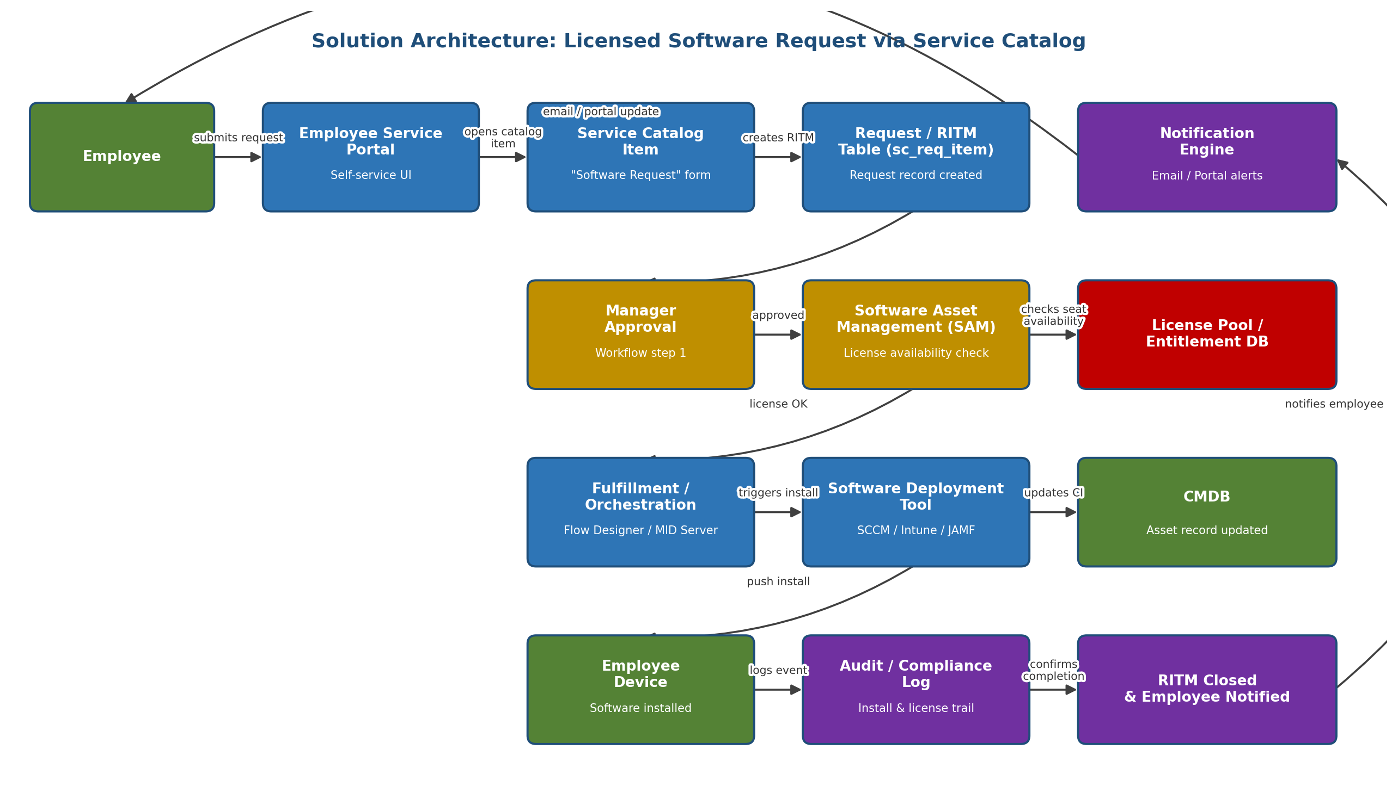
Figure 1: Architecture and data flow for licensed software requests submitted through the Service Catalog

Narrative: An employee submits a software request through the Employee Self-Service Portal by selecting a Service Catalog item. This creates a Request Item (RITM). The request routes to the employee's manager for approval, then to Software Asset Management (SAM) to confirm a license seat is available in the Entitlement/License Pool. Once approved and license-checked, a Fulfillment/Orchestration flow triggers the Software Deployment Tool (e.g., SCCM, Intune, or JAMF) to push the install to the employee's device, and updates the CMDB with the new asset/software relationship. The install and license usage are written to an audit/compliance log, the RITM is closed, and the employee is notified via email and the Portal.

Reference (pattern adapted from): https://aws.amazon.com/blogs/industries/voice-applications-in-clinical-research-powered-by-ai-on-aws-part-1-architecture-and-design-considerations/

